The Effect of Rocket Dimensions on Flight Apogee

Math 740/840  
Fall 2019

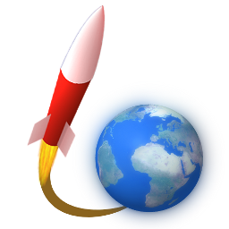

Members

Charlie Nitschelm  
Lucas Simmonds

# Abstract

When designing a rocket, it is very important to understand the impact each part has on the overall performance of the rocket. Using a well-tested flight prediction program, OpenRocket, it is possible to input the parameters of a rocket and its launch conditions to predict its overall flight path, and most importantly, its maximum height reached, or flight apogee. The Spaceport America Cup competition, which is hosted every year at Spaceport America in New Mexico in June 2020 requires teams to design a rocket capable of reaching as close to 10,000 feet as possible. This mission requires a close and defined understanding of predicting the flight apogee before manufacturing to ensure that the rocket, when constructed, is estimated to hit as close to that apogee as possible. The primary rocket features will be varied and simulated in a Custom Design in JMP to predict the best feature selection to hit a apogee of exactly 10,000 feet if the rocket was manufactured exactly as designed.

# Methods and Materials

OpenRocket, the software being used to predict the result the study is looking for, can be assumed as a true result with no error. Being a simulation, no physical material is needed except the use of a computer capable of running these simulations that can be quite demanding. All fight forces must be calculated iteratively, including but not limited to the thrust, drag and weight forces. A standard one-stage rocket was designed with 4 different varying factors, each with a high, medium and low setting. Due to considering the simulation as a true value, no repeats must be done. A randomization scheme is not needed as well for the same reason. The factors varied were: nose cone length, nose cone shape parameter, body tube length and environment temperature

# Results

# Confirmatory Trials

# Conclusion